How to Convert CSV to OV2 for Tom Tom Device

1.) Connect your Tom Tom device to your computer.
2.) Go to the Matteson website where the Rhode Island Cemeteries.csv file is located.
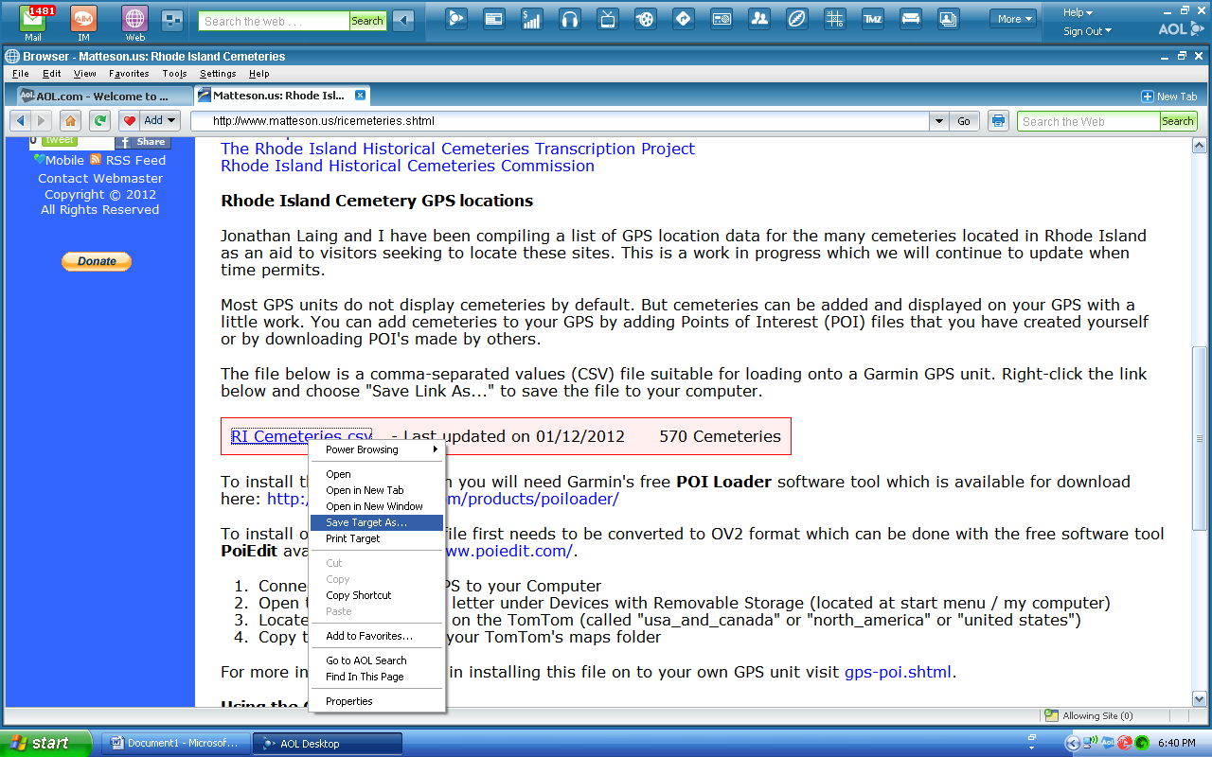
3.) Right click and Save target as and save the csv file to a location you will remember.
4.) Next Open up the utility
5.) If this is the first time you are trying this go to step 8

6.) If you are updating the file, first click on the folder Rhode Island Cemeteries on the upper right and highlight all the existing entries and click the red x to remove them.

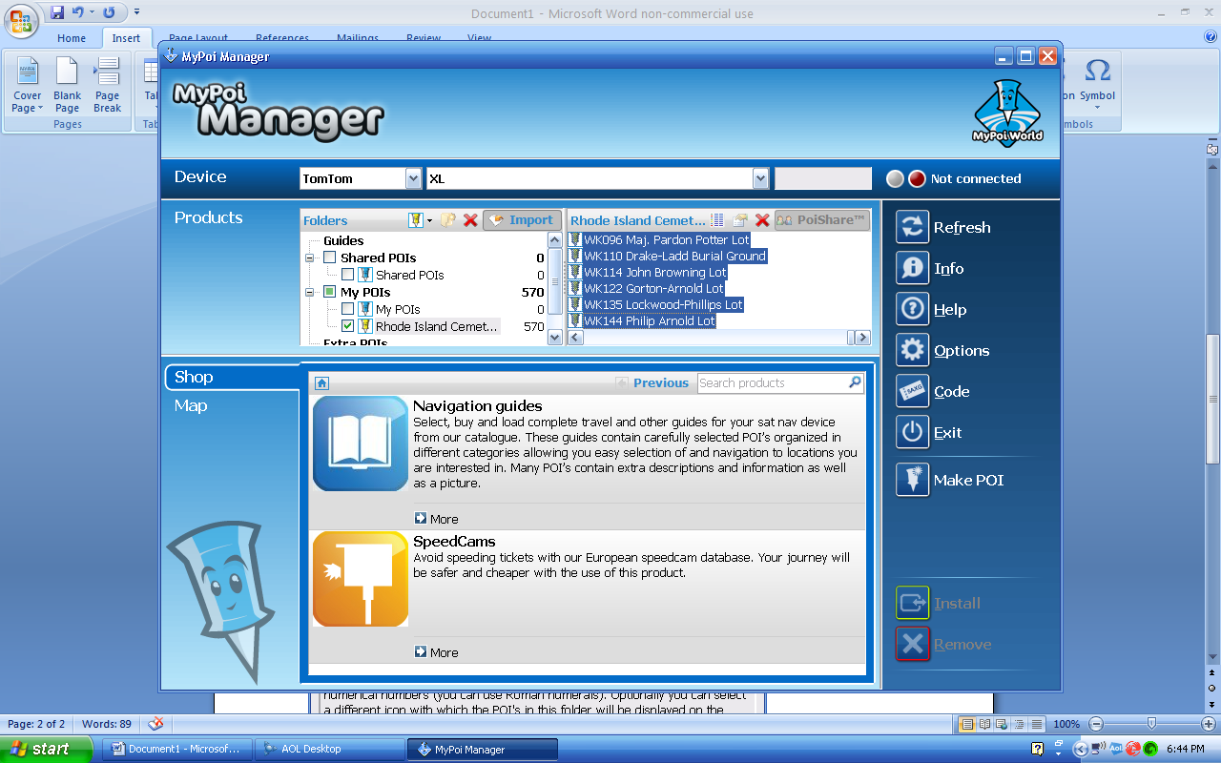
7.) You will see a message verifying you want to delete them. Click yes.
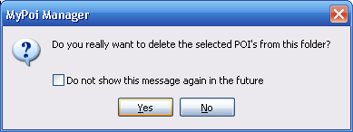

8.) Next Click on the Import button on the top Left box.
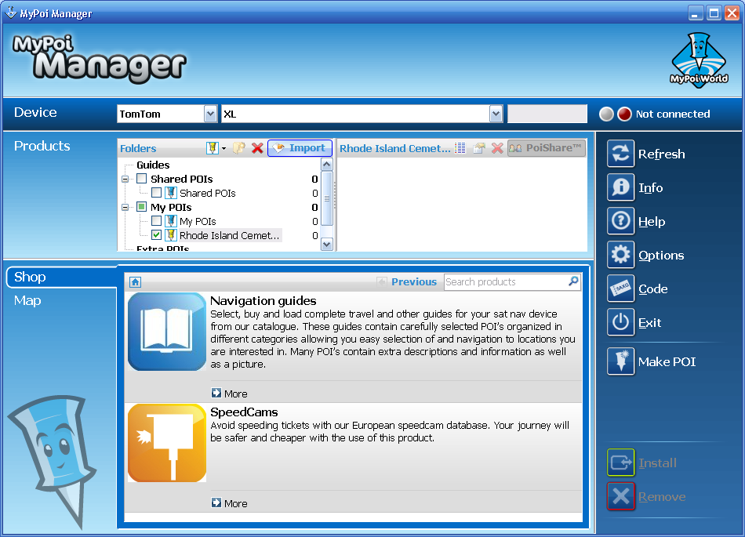

9.) Next Pick the RI Cemeteries.csv file. The preview will show the data available. Change the Target folder to Rhode Island Cemeteries.
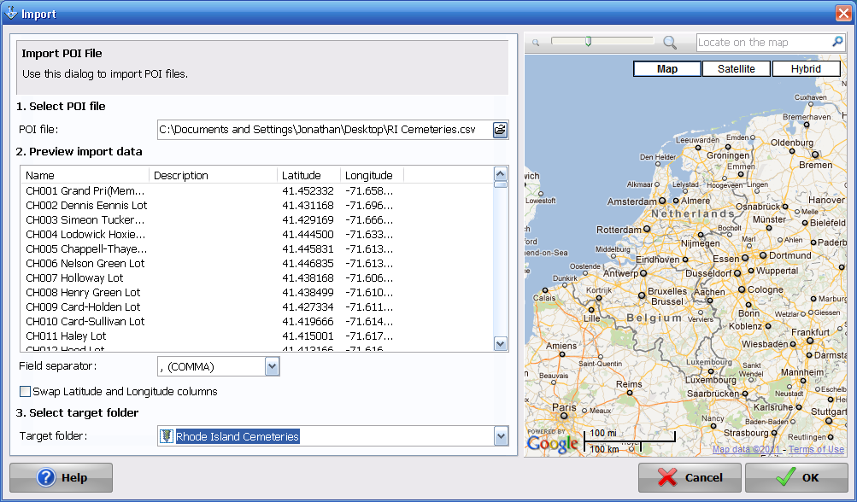
10.) If the folder is not available, just click on New folder and the popup will appear below. Just rename it to Rhode Island Cemeteries and click OK.
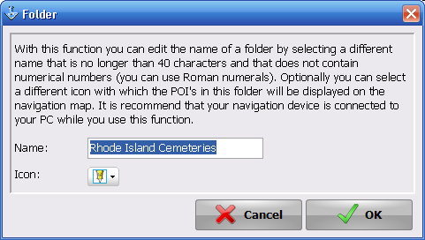

11.) Now you will see them reloaded into the program like below.
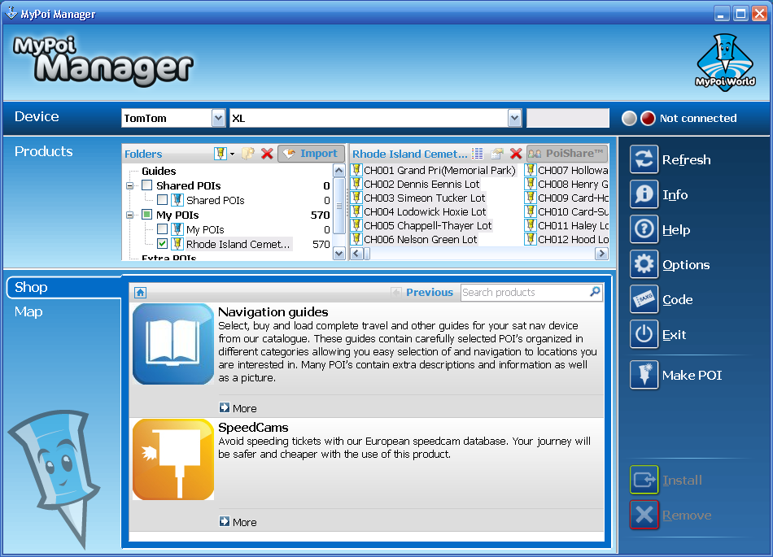
12.) If you notice that the button shows not connected, make sure that your Tom Tom is turned on and connected to the PC.

13.) Next go to your Tom Tom and find the Rhode Island Cemeteries.ov2 file and remove the file.
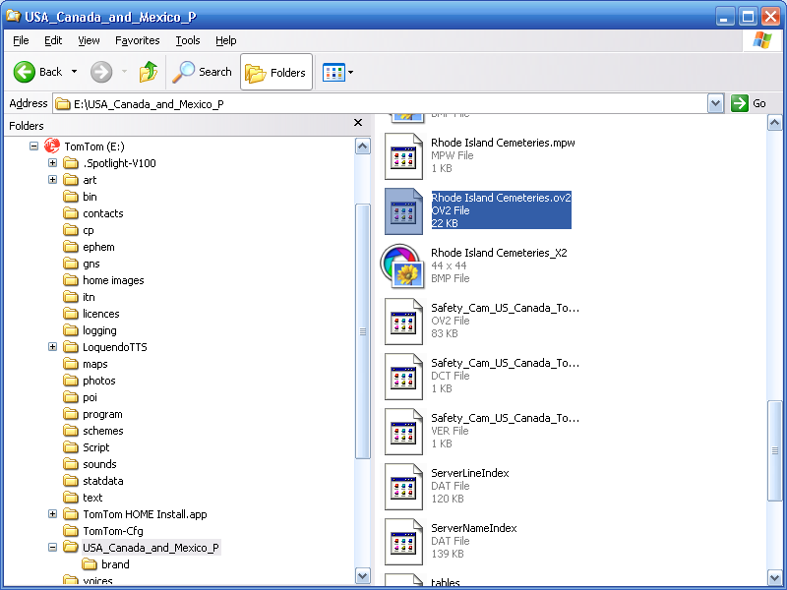

13.) Next re high light all your Entries in Rhode Island Cemeteries and click Install to recreate the Rhode Island Cemeteries.ov2 file.
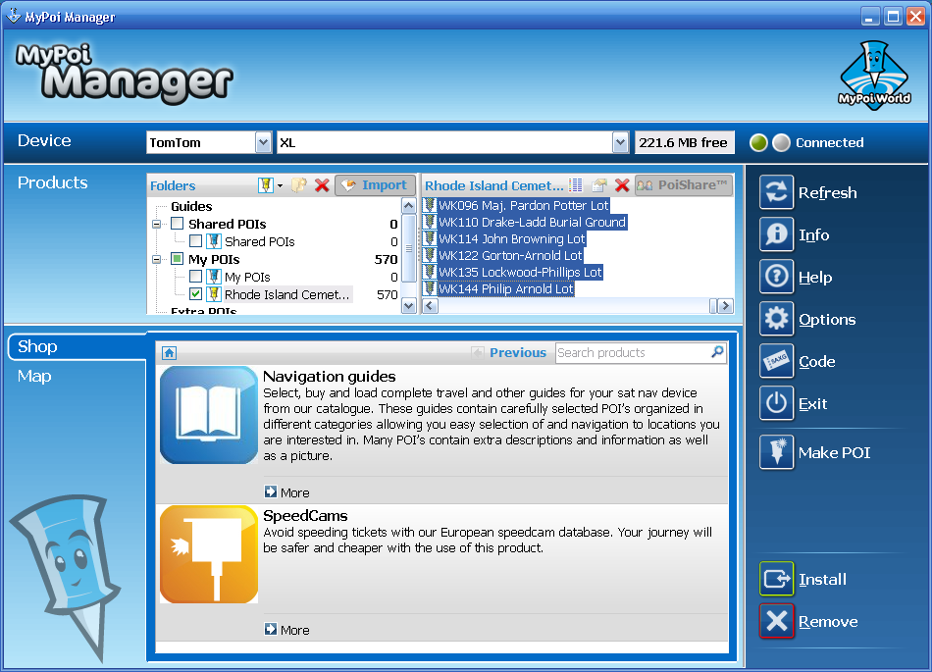

14.) Next you will see this pop up. This verifies that the file has be recreated. Click Close when finished.
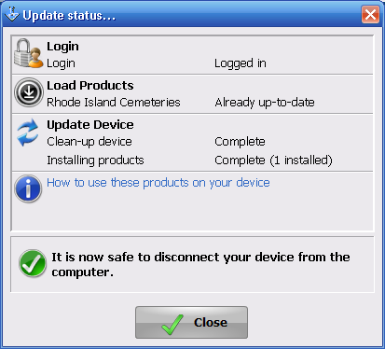

15.) This should now show up in the same directory as before on your Tom Tom.
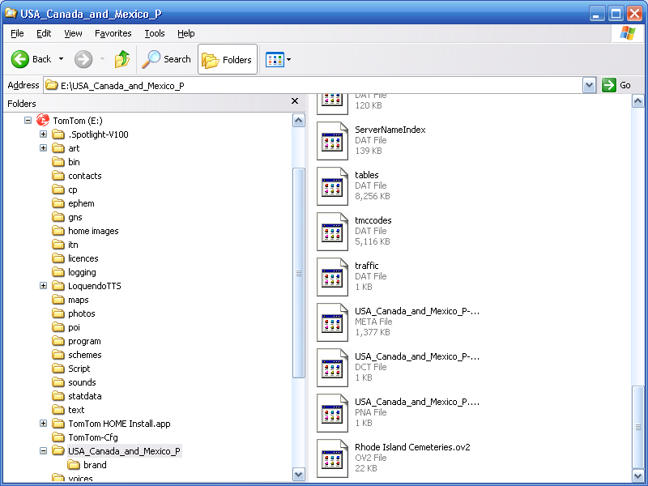

16.) Note If you have a Bitmap that you would like to use in place of the generic one loaded. Find the Rhode Island Cemeries BMP file and remove it and replace it with the BMP file you want to use. Keep in mind that the name has to be exactly the same for it to work correctly in your Tom Tom.
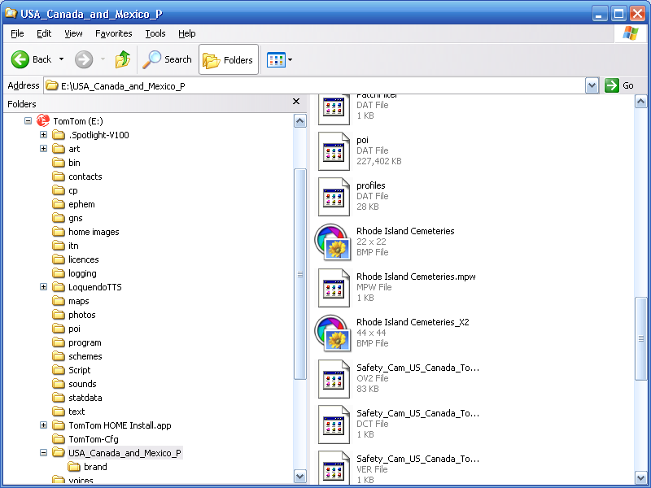
17.) Now you can close out of MY POI Manager application.
18.) To view the
19. These should be the steps to route to a specific site.
Go to Plan Route, Depart from Home, Navigate to Point of Interest, Poi in City, Pick your location, type for example WG076 to find the cemetery and pick name, Click select and done to map route specifically to the site.
20.) To add the Rhode Island Cemeteries to show on the road maps, go to Browse Map, Choose POI’s and find Rhode Island Cemeteries and make sure that it is checked and click done.
21. To set alarm go to Options, Manage POI’s, Warn when near POI and pick Rhode Island Cemeteries. Set yardage you want to be notified by and click OK. Pick Brief Spoken warning seems to be a good option and click Done. Leave Warn only if POI is on route unchecked as these are off road in many instances and click Done twice.
You should be set up now to use this tool.

